The Rise in Car Thefts

A White Paper Presented to Amirfarrokh Iranitalab

For Bellevue Class DSC 680

By James Mulvihill

Car Theft has risen almost 80% from 2019 to 2023 nationwide. [1] Breaking down this by city, you can see the rise in the chart below for five of the biggest cities in the United States. Although the focus of this whitepaper is not necessarily why this happening, it is interesting to note that the rate increased around the time of Covid. Also, part of the reported increase was due to more police agencies reporting to the FBI’s National Incident-Based Reporting System (NIBRS). [2] Many more agencies in the past five years have started reporting to NIBRS to the point where about 84% of the United States population is covered. Still the number of incidents per capita has risen substantially.

The above stacked area chart shows the number of car thefts in major US cities, all of which have risen dramatically.

My goal is to figure out what can be done about the increase in car theft. The most interesting finding is that Kia and Hyundai vehicles have been targeted much more proportionally than other cars. There are many reasons why they have been targeted. [3] First, they don’t have engine immobilizers that stop cars from starting without a key. Also, TikTok and other social media videos were made showing how easy it is to start the cars without a key.

For this project I used R Studio to do my analysis of the data and created a Markdown file containing all the charts on this report. I got most of the data from Bellevue Data Science class 640. [4] The other secondary, independent source was from VICE News. [5] Most of the data was present in these sources with only a few missing values. Many of the columns were unnecessary for my projects so they were dropped. I had to do a lot of aggregation work to present the graphs in this report.

Above is a summary chart of the combined totals of car thefts over 2019-2022, specifically looking at Kias. While it may not look like a lot proportionally. The later years saw the greatest number of thefts. Additionally, Hyundai and Kias are stolen much more frequently in some cities compared to others. This is especially true of Milwaukee, where Kia Thefts, at their height in 2021, accounted for 66% of the vehicle thefts citywide as the below donut chart shows. The obvious conclusion is that, while it may not be happening everywhere, at least cities like Milwaukee, Kias are being targeted at much greater rate than other cars.

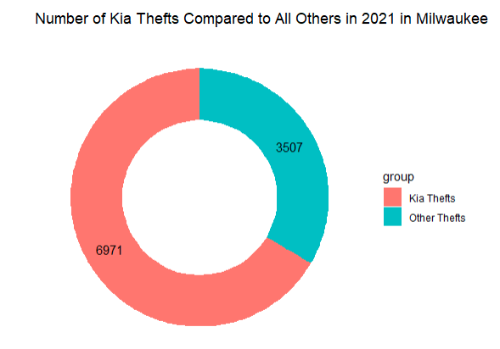

For my application and recommendation. I would recommend that the Milwaukee Police department (and any other police departments with similar statistics), should purchase bait cars and purchase whichever type of cars are being targeted, in this case Kias. Bait cars are police owned cars that are used in crime hotspots to catch people trying to steal cars red-handed. My supporting reasons for this are that 1: Car thefts are on the rise across the country and 2. Kias are being disproportionately targeted for theft, especially in Milwaukee.

As for ethical considerations, I don’t think there are too many problems to worry about. The data is publicly available and only consists of aggregates that hide individual crimes and suspects. There could be some skew in the reported data and what the true number of car thefts nationwide since not all police agencies report to NIBRS yet, and, since each year from 2019 to 2023 has seen a slight uptick in the number of agencies reporting, the growth in car theft might seem larger than it truly is. However, that doesn't matter too much, because it is still true that the per capita rate of car thefts has been increasing, especially in major cities that have long been reporting to NIBRS. Furthermore, this wouldn’t affect the percentage of Kias being stolen compared to other cars.

1. References:

   *FBI Releases Motor Vehicle Theft, 2019—2023 | Federal Bureau of Investigation*. (2019). Federal Bureau of Investigation. https://www.fbi.gov/news/press-releases/fbi-releases-motor-vehicle-theft-2019-20231
2. *FBI Finds Motor Vehicle Theft Steadily Increasing in United States*. (2024). Asisonline.org. https://www.asisonline.org/security-management-magazine/latest-news/today-in-security/2024/august/auto-theft-united-states-fbi/
3. Spencer, C. (2024, March 11). *Kia and Hyundai Thefts Still Up After Upgrade*. MPR News. https://www.mprnews.org/story/2024/03/11/kia-and-hyundai-owners-continue-to-report-car-theft-after-free-security-upgrades
4. <https://content.bellevue.edu/cst/dsc/640/2024Update/Datasets/KiaHyundaiMilwaukeeData.csv>, <https://content.bellevue.edu/cst/dsc/640/2024Update/Datasets/carTheftsMap.csv>, <https://content.bellevue.edu/cst/dsc/640/2024Update/Datasets/kiaHyundaiThefts.csv>
5. <https://docs.google.com/spreadsheets/d/1-6614t_Ata5k7oESrm-HAdF1uOe8aPGRaQECl44GYeE/edit?pli=1&gid=0#gid=0>

   Questions:

   1. What other big cities have a similar proportion of Kia and Hyundai vehicles stolen?
   2. Was there any instance of disagreement among your data sources?
   3. What is the number of car thefts per capita?
   4. Why isn’t every police agency required to submit reports to NIBRS?
   5. How do bait cars work in practice?
   6. Are bait cars worth it given how much they would cost?
   7. Where have bait cars been used successfully?
   8. Where have bait cars been used unsuccessfully?
   9. How often should the data be reviewed?
   10. Is it getting better now that Kia and Hyundai have released some security upgrades?

  